**IBM Cloud Pak for Integration**

**Installation of IBM Cloud Pak for Integration Operator.**

1. Log into the **OpenShift Web Console** with your OpenShift Credentials.

2. Expand **Operator** menu and click **OperatorHub**. In the OperatorHub window **search IBM Cloud Pak for Integration** or c**p4i** and click on the tile **IBM Cloud Pak for Integration.**

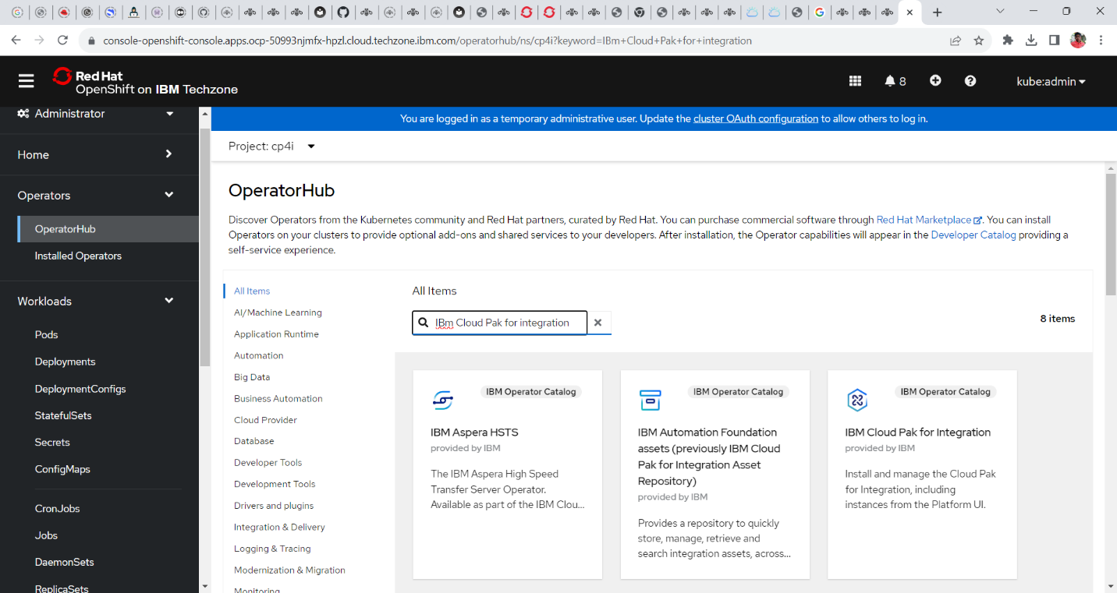

3. Read the document for your understanding and click on the option **Install**.

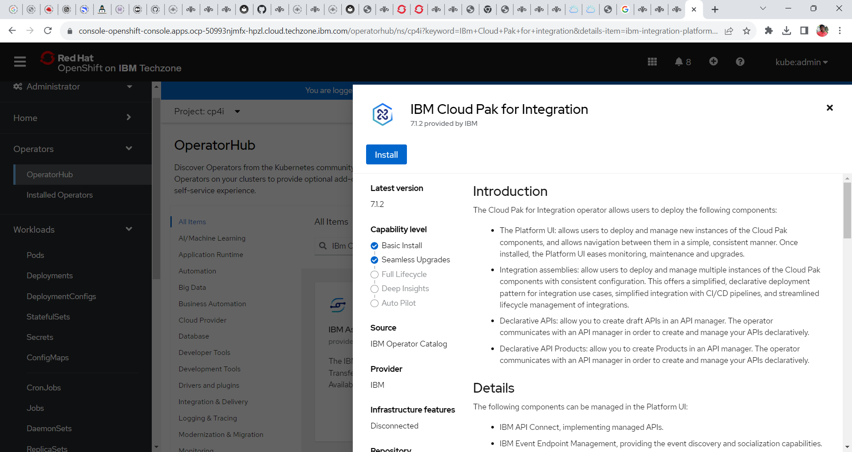

4. In the install window provide the following configuration

**Update Channel: 6.0**

**Installation Mode: All Namespace**

**Installed Namespace: openshift-operators**

**Update Approval: Automatic**

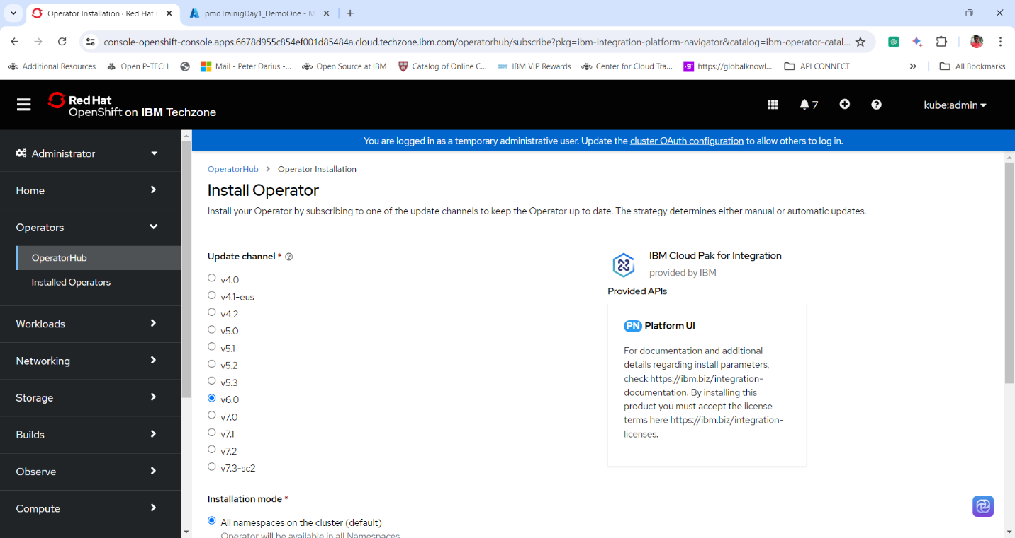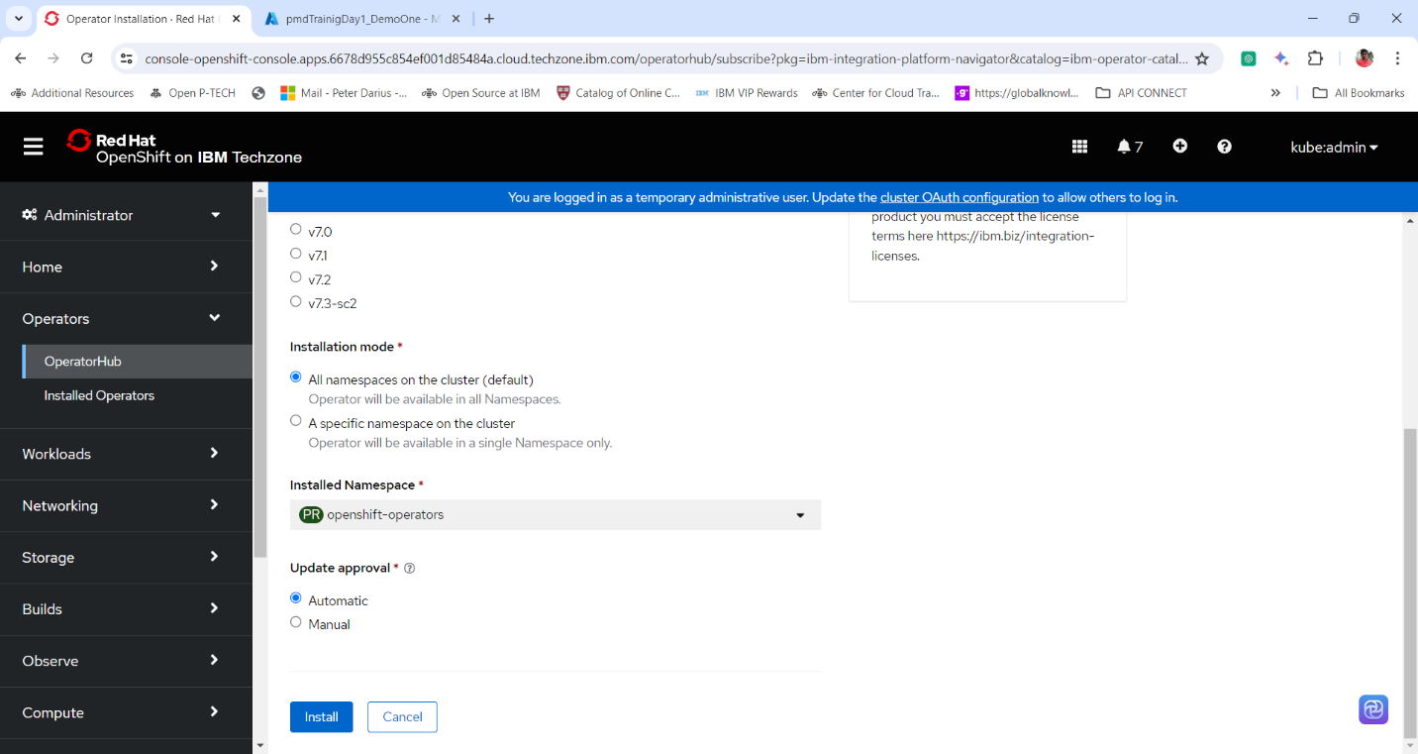

5. Click **Install.**

6. After the installation of the operator click **View Operator** to view the details of the installed operator



